Biological Science, 8e (Freeman)

Chapter 1 Biology: The Study of Life
- Which of the following is NOT related to the five fundamental characteristics of life?
- A bacterial cell divides to produce two cells.
- Sugars are transported on carrier proteins into cells across the plasma membrane.
- Sugars are broken down inside cells to produce energy.
- The gene that specifies skin color in frogs is expressed during its development from a tadpole into an adult frog.
- Giraffes have longer necks so that they can reach food sources unavailable to other animals.
Answer: E
Bloom’s Taxonomy: Applying/Analyzing
V&C Core Concept: EM
V&C Core Comp: PS
LO/EO: 1.1, 1.2; 1.1.1
Section: 1.1
- Which of the following statements best describes a characteristic that may be associated with both living organisms and nonliving matter?
- Reproduction by passing on genetic information to future generations.
- Composed of cells.
- Capable of evolution.
- Able to produce heat as a byproduct of chemical reactions.
Answer: D
Bloom’s Taxonomy: Remembering/Understanding
V&C Core Concept: EM
V&C Core Comp: PS
LO/EO: 1.1; 1.1.1
Section: 1.1.1
- Which of the following statements is an inaccurate example of how the living organism in the scenario exemplifies a characteristic feature of living organisms?
- Photosynthetic bacteria meet the energy requirement, as they are able to convert energy from sunlight into the chemical energy they store in sugars.
- As humans, we meet the cell requirement because even though we are made of tissues and organs, all of those components are made of specialized types of cells.
- English bulldogs would meet both the information and ability to replicate requirements because when they have a litter of puppies, we would expect the progeny to be English bulldogs due to their DNA from the parents.
- Monarch butterflies meet the evolution requirement because each of them will look different as adults (butterflies) than they do as juveniles (caterpillars) which demonstrate their ability to change over time.
- All of the statements are proper examples of how that organism exemplifies particular characteristics of life.
Answer: D
Bloom’s Taxonomy: Applying/Analyzing
V&C Core Concept: EM
V&C Core Comp: PS
LO/EO: 1.1, 1.4; 1.1.1
Section: 1.1.1, 1.4.1
- Pasteur’s experiments demonstrated that ________.
- cells cannot survive in swan-necked flasks
- in order to grow, cells need to be supplied with oxygen
- spontaneous generation can only occur if nutrient broth is left open to the environment
- sterilizing nutrient broth prevents spontaneous generation
- preexisting cells present in the air can grow in sterilized nutrient broth
Answer: E
Bloom’s Taxonomy: Remembering/Understanding
V&C Core Concept: EM
V&C Core Comp: PS
LO/EO: 1.2; 1.2.2
Section: 1.2
- Recall Pasteur’s experiment on spontaneous generation. If he had just warmed the nutrient-rich broth, rather than boiled it, what would have been the likely outcome of his experiment? Cells would ________.
- not have appeared in either flask
- have appeared in both flasks
- have appeared in the swan-neck but not the straight-neck flask
- have appeared in the straight-neck but not the swan-neck flask
Answer: B
Bloom’s Taxonomy: Applying/Analyzing
V&C Core Concept: EM
V&C Core Comp: PS
LO/EO: 1.2; 1.2.2
Section: 1.2
- Spontaneous generation ________.
- was demonstrated to occur under normal laboratory conditions by Pasteur
- apparently occurred at least once–when life on Earth began
- occurs every time a new species evolves from a preexisting species
- addresses the formation of new cells from existing cells
Answer: B
Bloom’s Taxonomy: Remembering/Understanding
V&C Core Concept: EM
V&C Core Comp: PS
LO/EO: 1.2; 1.2.3
Section: 1.2
- Recall Pasteur’s experiment on spontaneous generation. What would the expected results have been if Pasteur’s swan-neck experiment hypothesis were incorrect?
- Cells would not have appeared in either flask.
- Cells would have appeared in both flasks.
- Cells would have appeared in the swan-neck but not the straight-neck flask.
- Cells would have appeared in the straight-neck but not the swan-neck flask.
Answer: B
Bloom’s Taxonomy: Applying/Analyzing
V&C Core Concept: EM
V&C Core Comp: PS
LO/EO: 1.2; 1.2.2
Section: 1.2.1
- Algae in the genus Caulerpa typically grow to a length of over half a meter and have structure similar to stems, leaves, and roots. Reproduction occurs when adults produce sperm and eggs that fuse to form offspring. Each adult Caulerpa consists of just a single cell, however. Which of the following statements is TRUE?
- Caulerpa violate the pattern component of the cell theory that all organisms consist of cells.
- Caulerpa violate the process component of the cell theory that all cells come from preexisting cells.

- Caulerpa violate both the pattern and process components of the cell theory.
- The existence of Caulerpa is consistent with the cell theory.
Answer: D
Bloom’s Taxonomy: Applying/Analyzing
V&C Core Concept: SF
V&C Core Comp: PS
LO/EO: 1.2; 1.2.1
Section: 1.2
- Cells are ________.
- only found in pairs because single cells cannot exist independently
- limited in size to 200 and 500 micrometers in diameter
- characteristic of eukaryotic but not prokaryotic organisms
- characteristic of prokaryotic and eukaryotic organisms
Answer: D
Bloom’s Taxonomy: Remembering/Understanding
V&C Core Concept: SF
V&C Core Comp: PS
LO/EO: 1.2; 1.2.1
Section: 1.2
- The cell theory states that all cells come from preexisting cells. If this is the case, why are the cells in a multicellular organism so different from one another?
- Cells in a multicellular organism are exposed to different energy sources allowing them to develop different features.
- During cell division, the genetic information that is replicated and passed onto the daughter cells is different from the original cell.
- The genetic information of each cell is copied and passed on to the daughter cells and the molecular machinery that reads that genetic information is different in each cell.
- The genetic information of each cell is copied and passed on to the daughter cells and the molecular machinery makes copies of particular genes in different cells to generate different features in those cells.
Answer: D
Bloom’s Taxonomy: Remembering/Understanding
V&C Core Concept: I
V&C Core Comp: PS
LO/EO: 1.3; 1.3.1
Section: 1.3
- The discovery of the structure of DNA was useful because ________.
- it helped scientists understand how the information in DNA could be used to acquire ATP for the cell
- it inferred that genetic information flowed from messenger RNA to DNA to protein
- it suggested a mechanism for copying and preserving the genetic material
- it revealed how mRNA was used to make proteins
Answer: C
Bloom’s Taxonomy: Remembering/Understanding
V&C Core Concept: SF
V&C Core Comp: PS
LO/EO: 1.3; 1.3.1
Section: 1.3
- Double helical DNA ________.
- serves as a template for protein synthesis
- is used to synthesize messenger RNA
- contains two identical single strands of DNA
- must be accurately copied to ensure variation in organisms
Answer: B
Bloom’s Taxonomy: Remembering/Understanding
V&C Core Concept: I
V&C Core Comp: PS
LO/EO: 1.3; 1.3.1
Section: 1.3
- In comparison to eukaryotes, prokaryotes ________.
- do not require ATP for energy while eukaryotes do require ATP
- are more closely related to archaea than eukaryotes
- lack a nucleus, while eukaryotes have a nucleus
- are always single-celled while eukaryotes are always multicellular
- have chromosomes composed of single-stranded DNA, while eukaryotes have chromosomes composed of double-stranded DNA
Answer: C
Bloom’s Taxonomy: Remembering/Understanding
V&C Core Concept: SF, E

V&C Core Comp: PS
LO/EO: 1.5; 1.5.2
Section: 1.5
- Which of these provides evidence of the common ancestry of all life?
- Ubiquitous use of catalysts by living systems
- Near universality of the genetic code
- Structure of the nucleus
- The flow of genetic information from DNA to RNA to protein
- The directionality of protein synthesis
Answer: B
Bloom’s Taxonomy: Applying/Analyzing
V&C Core Concept: SF, E, I
V&C Core Comp: PS
LO/EO: 1.5; 1.5.1
Section: 1.5
- Cotton-topped tamarins are small primates with tufts of long white hair on their heads. While studying these creatures, you notice that males with longer hair get more opportunities to mate and father more offspring. To test the hypothesis that having longer hair is adaptive in these males, you should ________.
- test whether other traits in these males are also adaptive
- look for evidence of hair in ancestors of tamarins
- determine if hair length is heritable
- test whether males with shaved heads are still able to mate
Answer: C
Bloom’s Taxonomy: Applying/Analyzing
V&C Core Concept: E
V&C Core Comp: PS
LO/EO: 1.4; 1.4.2
Section: 1.4
The following experiment is used for the corresponding question(s).
A researcher discovered a species of moth that lays its eggs on oak trees. Eggs are laid at two distinct times of the year: early in spring when the oak trees are flowering and in midsummer when flowering is past. Caterpillars from eggs that hatch in spring feed on oak flowers and look like oak flowers. But caterpillars that hatch in summer feed on oak leaves and look like oak twigs.
How does the same population of moths produce such different-looking caterpillars on the same trees? To answer this question, the biologist caught many female moths from the same population and collected their eggs. He put at least one egg from each female into eight identical cups. The eggs hatched, and at least two larvae from each female were maintained in one of the four temperature and light conditions listed below.

Temperature | Day Length
Springlike | Springlike
Springlike | Summerlike
Summerlike | Springlike
Summerlike | Summerlike

In each of the four environments, one of the caterpillars was fed oak flowers; the other, oak leaves. Thus, there were a total of eight treatment groups (4 environments × 2 diets).
- Refer to the figure above. Which one of the following is NOT a plausible hypothesis to explain the differences in caterpillar appearance observed in this population?
- The longer day lengths of summer trigger the development of twiglike caterpillars.
- The cooler temperatures of spring trigger the development of flowerlike caterpillars.
- Differences in air pressure, due to differences in elevation, trigger the development of different types of caterpillars.
- Differences in diet trigger the development of different types of caterpillars.
Answer: C
Bloom’s Taxonomy: Applying/Analyzing
V&C Core Concept: SF, E
V&C Core Comp: PS
LO/EO: 1.4; 1.4.2
Section: 1.4
- Refer to the figure above. In every case, caterpillars that feed on oak flowers looked like oak flowers. In every case, caterpillars that were raised on oak leaves looked like twigs. These results support which of the following hypotheses?
- The longer day lengths of summer trigger the development of twiglike caterpillars.
- Differences in air pressure, due to elevation, trigger the development of different types of caterpillars.
- Differences in diet trigger the development of different types of caterpillars.
- The differences are genetic. A female will produce either all flowerlike caterpillars or all twiglike caterpillars.
Answer: C
Bloom’s Taxonomy: Applying/Analyzing
V&C Core Concept: SF, E
V&C Core Comp: PS
LO/EO: 1.4; 1.4.2
Section: 1.4
- Refer to the figure above. Recall that eggs from the same female were exposed to each of the eight treatments used. This aspect of the experimental design tested which of the following hypotheses?
- The longer day lengths of summer trigger the development of twiglike caterpillars.
- Differences in air pressure, due to elevation, trigger the development of different types of caterpillars.
- Differences in diet trigger the development of different types of caterpillars.
- The differences are genetic. A female will produce either all flowerlike caterpillars or all twiglike caterpillars.
Answer: D
Bloom’s Taxonomy: Applying/Analyzing
V&C Core Concept: SF, E
V&C Core Comp: PS
LO/EO: 1.4; 1.4.2
Section: 1.4
- Recall the caterpillar experiment in which caterpillars born in the spring looked like flowers, and caterpillars born in the summer looked like twigs. What is the most likely selective advantage for this difference in body shape?
- Looking like their food sources allows the caterpillars to move through their environment more efficiently.
- Development into the adult moth form is faster for caterpillars shaped like twigs than like flowers.
- Looking like their food source lets the caterpillars blend into their surroundings, reducing predation.
- Looking like their food source will increase the caterpillars’ feeding efficiency; this would increase their growth rate and survival rate.
Answer: C
Bloom’s Taxonomy: Applying/Analyzing
V&C Core Concept: SF, E
V&C Core Comp: PS
LO/EO: 1.4; 1.4.2
Section: 1.4
- Protists and bacteria are grouped into different domains because ________.
- protists eat bacteria
- bacteria cannot generate their own ATP; protists can
- protists have a membrane-bounded nucleus, which bacterial cells lack
- bacteria decompose protists
- protists lack the genetic diversity that bacteria have
Answer: C
Bloom’s Taxonomy: Remembering/Understanding
V&C Core Concept: SF, E
V&C Core Comp: PS
LO/EO: 1.5; 1.5.2
Section: 1.5
- You have isolated and purified a new species of cells from the rain forest, and you want to place this new species in the appropriate branch of the tree of life. You sequence the ribosomal RNA genes from these cells and discover that for one particular region of the ribosomal RNA gene (the rRNA) the RNA sequence is AAUGAAGG. You have sequences from the same region of the ribosomal genes (the rRNA) from each of these species: bacteria, eukaryote, and archaea, which are listed below.
bacteria AUAGAUGG
eukaryote AAAGAAGG
archaea AAUGGAGU
Based on these sequence results, to which branch of the tree of life should you assign this new species?
- Archaea
- Bacteria
- Eukaryote
- Bacteria and archaea
- There is not enough information.
Answer: C
Bloom’s Taxonomy: Applying/Analyzing
V&C Core Concept: E
V&C Core Comp: PS
LO/EO: 1.5; 1.5.1
Section: 1.5

- You have isolated and purified a new species of cells from the rain forest, and you want to place this new species in the appropriate branch of the tree of life. You sequence the ribosomal RNA genes from these cells and discover that for one particular region of the ribosomal RNA gene (the rRNA) the RNA sequence is AAUGAAGG. You have sequences from the same region of the ribosomal genes (the rRNA) from each of these species: bacteria, eukaryote, and archaea, which are listed below.
bacteria AUAGAUGG
eukaryote AAAGAAGG
archaea AAUGGAGU
Based on these sequence results, which reasonable expectation could be made about the new species?
- It is composed of cells that contain a membrane-bound nucleus.
- It is an animal, likely one that has a spinal cord.
- It is composed of cells that do not contain a membrane-bound nucleus.
- It is a single-celled organism.
- There is not enough information.
Answer: A
Bloom’s Taxonomy: Applying/Analyzing
V&C Core Concept: E
V&C Core Comp: PS
LO/EO: 1.5; 1.5.1, 1.5.2
Section: 1.5
- How does a scientific theory differ from a scientific hypothesis?
- Theories are proposed to test scientific hypotheses.
- Theories are usually an explanation for a more general phenomenon; hypotheses typically address more specific issues.
- Hypotheses are usually an explanation for a more general phenomenon; theories typically address more specific issues.
- Confirmed theories become scientific laws; hypotheses become theories.
Answer: B
Bloom’s Taxonomy: Remembering/Understanding
V&C Core Concept: S
V&C Core Comp: PS
LO/EO: 1.6; 1.6.2
Section: 1.6

- Louis Pasteur’s experiment was designed well because ________.
- simple equipment was used
- a major question, spontaneous generation, was tested
- the possible outcomes led to distinct, unambiguous conclusions
- the experiment was a success
Answer: C
Bloom’s Taxonomy: Applying/Analyzing
V&C Core Concept: S
V&C Core Comp: PS
LO/EO: 1.6; 1.6.3
Section: 1.6
- Recall the experiment on ant navigation. To run a controlled experiment, what parameters were held constant for the test group of 75 ants?
- Stride number
- Leg length
- Stride number, leg length, and environmental temperature
- All variables except leg length
Answer: D
Bloom’s Taxonomy: Remembering/Understanding
V&C Core Concept: S
V&C Core Comp: PS
LO/EO: 1.6; 1.6.3
Section: 1.6
- Your colleague proposes to test the mechanism of ant navigation by placing a food source 7 meters (m) from the nest. She then takes ants from the nest and places them in a spot that is 4 m from the nest and 3 m from the food source. Based on the previous data, where do you expect the ants to start searching for their nest on their return trip?
- After they have traveled 3 m from the food source
- After they have traveled 4 m from the food source
- After they have traveled 7 m from the food source
- As soon as they leave the food source
Answer: A
Bloom’s Taxonomy: Applying/Analyzing
V&C Core Concept: S
V&C Core Comp: PS, QR
LO/EO: 1.6; 1.6.2
Section: 1.6
- For many years, no one bothered to test the food-competition hypothesis for why giraffes have long necks. Why?
- It had been much too difficult to test.
- The hypothesis was so plausible that no one thought to question it.
- They tried, but the results were inconclusive.
- The hypothesis did not make clear predictions that could be tested.
Answer: B
Bloom’s Taxonomy: Remembering/Understanding
V&C Core Concept: E
V&C Core Comp: PS
LO/EO: 1.6; 1.6.2
Section: 1.6
- A friend of yours calls to say that his car would not start this morning. He asks for your help. You say that you think the battery must be dead. If so, then jump-starting the car from a good battery will solve the problem. In doing so, you are ________.
- testing a theory for why the car will not start
- making observations to inspire a theory for why the car will not start
- stating a hypothesis and using that hypothesis to make a testable prediction
- comparing multiple hypotheses for why the car will not start
Answer: C
Bloom’s Taxonomy: Applying/Analyzing
V&C Core Concept: S
V&C Core Comp: PS
LO/EO: 1.6; 1.6.2
Section: 1.6
- Agrobacterium infects plants and causes them to form tumors. You are asked to determine how long a plant must be exposed to these bacteria to become infected. Which of the following experiments will provide the best data to address that question?
- Measure the number of tumors formed on plants, which are exposed to different concentrations of Agrobacterium for different lengths of time.
- Measure the number of tumors formed on a plant when exposed to various concentrations of Agrobacterium.

- Measure the concentration of Agrobacterium in different soil environments where the plants grow.
- Measure the number of tumors formed on plants, which are exposed to a known concentration of Agrobacterium for different lengths of time.
Answer: D
Bloom’s Taxonomy: Applying/Analyzing
V&C Core Concept: S
V&C Core Comp: PS
LO/EO: 1.6; 1.6.3
Section: 1.6
- Agrobacterium infects plants and causes them to form tumors. You determine that tumor formation requires a large amount of the plant’s energy for tissue formation. How might this change the number of offspring a plant produces, and what is the most likely explanation for this change?
- The number of offspring should increase because in general, illness increases the reproductive output of organisms.
- The number of offspring should increase because the bacteria will provide energy for the plant.
- The number of offspring should decrease because the plant will divert energy from reproduction to tumor formation.
- There should be no effect of infection on offspring production because energy for reproduction is independent of infection.
Answer: C
Bloom’s Taxonomy: Applying/Analyzing
V&C Core Concept: S
V&C Core Comp: PS
LO/EO: 1.6; 1.6.3
Section: 1.6
Use the following information when answering the corresponding question(s).
In 1668, Francesco Redi performed a series of experiments on spontaneous generation. He began by putting similar pieces of meat into eight identical jars. Four jars were left open to the air, and four were sealed. He then did the same experiment with one variation: Instead of sealing four of the jars completely, he covered them with gauze (the gauze excluded the flies while allowing the meat to be exposed to air). In both experiments, he monitored the jars and recorded whether or not maggots (young flies) appeared in the meat.
- Refer to the paragraph on Redi’s experiments. What hypothesis was being tested in the initial experiment with open versus sealed jars?
- Spontaneous generation is more likely during the long days of summer.
- The type of meat used affects the likelihood of spontaneous generation.
- Maggots do not arise spontaneously, but from eggs laid by adult flies.
- Spontaneous generation can occur only if meat is exposed to air.
Answer: C
Bloom’s Taxonomy: Applying/Analyzing
V&C Core Concept: S
V&C Core Comp: PS
LO/EO: 1.2, 1.6; 1.2.2, 1.6.2
Section: 1.2, 1.6
- Refer to the paragraph on Redi’s experiments. In both experiments, flies appeared in all of the open jars and only in the open jars. Which one of the following statements is correct?
- The experiment was inconclusive because Redi used only one kind of meat.
- The experiment was inconclusive because it did not run long enough.
- The experiment supports the hypothesis that spontaneous generation occurs in rotting meat.
- The experiment supports the hypothesis that maggots arise only from eggs laid by adult flies.
Answer: D
Bloom’s Taxonomy: Applying/Analyzing
V&C Core Concept: S
V&C Core Comp: PS
LO/EO: 1.2, 1.6; 1.2.2, 1.6.2
Section: 1.2, 1.6
- The best experimental design ________.
- includes a large sample size for each condition
- includes a control
- alters only one condition between the controls and the experimental condition
- includes a large sample size and a control and alters only one condition between the controls and the experimental condition
Answer: D
Bloom’s Taxonomy: Remembering/Understanding
V&C Core Concept: S
V&C Core Comp: PS
LO/EO: 1.6; 1.6.3
Section: 1.6
- In the process of science, which of these is NOT used to test a hypothesis?
- A theory
- A result
- An observation
- A control group
Answer: A
Bloom’s Taxonomy: Remembering/Understanding
V&C Core Concept: S
V&C Core Comp: PS
LO/EO: 1.6; 1.6.2
Section: 1.6
- A controlled experiment ________.
- is repeated many times to ensure that the results are accurate
- proceeds at a slow pace to guarantee that the scientist can carefully observe all reactions and process all experimental data
- includes at least two groups, one of which does not receive the experimental treatment
- includes at least two groups, one differing from the other by two or more variables
- includes one group for which the scientist controls all variables
Answer: C
Bloom’s Taxonomy: Remembering/Understanding
V&C Core Concept: S
V&C Core Comp: PS
LO/EO: 1.6; 1.6.3
Section: 1.6
- Which of the following are qualities of any good scientific hypothesis?
  - It is testable.
- It is falsifiable.
- It produces quantitative data.
- It produces results that can be replicated.
- I only
- II only
- III only
- I and II
- III and IV
Answer: D
Bloom’s Taxonomy: Remembering/Understanding
V&C Core Concept: S
V&C Core Comp: PS
LO/EO: 1.6; 1.6.3
Section: 1.6
- In an attempt to examine the idea of spontaneous generation, Pasteur conducted experiments utilizing different shaped flasks. Upon designing the study, he noted “that if cells come only from preexisting cells, then the different shapes of flasks would produce different growth observations,” which served as the ________ of the study.
- fact
- hypothesis
- theory
- proof
- process
Answer: B
Bloom’s Taxonomy: Remembering/Understanding
V&C Core Concept: S
V&C Core Comp: PS
LO/EO: 1.6; 1.6.2
Section: 1.6
- In presenting data that result from an experiment, a group of students show that most of their measurements fall on a straight diagonal line on their graph. However, two of their data points are “outliers” and fall far to one side of the expected relationship. What should they do?
- Change their experiment so that the outlier data points are eliminated.
- Average several trials, rule out the improbable results, and do not show them in the final work.
- Show all results obtained and then try to explore the reason(s) for these outliers.
- Redesign the experiment using a different hypothesis.
- Change the values on the graph so that only the straight diagonal line is produced.
Answer: C
Bloom’s Taxonomy: Evaluating/Creating
V&C Core Concept: S
V&C Core Comp: PS, QR
LO/EO: 1.6; 1.6.3
Section: 1.6
- Which of the following is the best description of a control for an experiment?
- The control group is kept in an unchanging environment.
- The control group is left alone by the experimenters.
- The control group is matched with the experimental group, except for one experimental variable.
- The control group is exposed to only one variable rather than several.
- Only the experimental group is tested or measured.
Answer: C
Bloom’s Taxonomy: Remembering/Understanding
V&C Core Concept: S
V&C Core Comp: PS
LO/EO: 1.6; 1.6.3
Section: 1.6
- Why is a scientific topic best discussed by people of varying points of view, from different subdisciplines, and representing diverse cultures?
- They can correct each other’s approach to make it scientific.
- Robust and critical discussion between diverse groups improves scientific thinking.
- Scientists can coordinate with others to conduct experiments in similar ways.
- This is a way of ensuring that everyone gets the same results.
- People need to exchange their ideas with other disciplines and cultures because everyone has a right to an opinion in science.
Answer: B
Bloom’s Taxonomy: Evaluating/Creating
V&C Core Concept: S
V&C Core Comp: PS, I, CC, SS
LO/EO: 1.6; 1.6.3
Section: 1.6
- A controlled experiment is one that ________.
- proceeds slowly enough that a scientist can make careful records of the results
- tests experimental and control groups in parallel
- is repeated many times to make sure the results are accurate
- controls all variables
- is supervised by an experienced scientist
Answer: B
Bloom’s Taxonomy: Remembering/Understanding
V&C Core Concept: S
V&C Core Comp: PS
LO/EO: 1.6; 1.6.3
Section: 1.6
- Which of the following statements best distinguishes scientific hypotheses from scientific theories?
- Hypotheses describe and theories explain.
- Hypotheses explain and theories describe.
- Hypotheses are usually narrower in scope; theories have broader explanatory power.
- Hypotheses are used in experiments. Theories are not tested.
- Hypotheses are generally supported by more evidence than theories.
Answer: C
Bloom’s Taxonomy: Remembering/Understanding
V&C Core Concept: S
V&C Core Comp: PS
LO/EO: 1.6; 1.6.2
Section: 1.6
- Which of the following best describes the logic of scientific inquiry?
- If I generate a testable hypothesis, tests and observations will support it.
- If my prediction is correct, it will lead to a testable hypothesis.
- If my observations are accurate, they will support my hypothesis.
- If my hypothesis is correct, I can expect certain test results.
- If my experiments are set up right, they will lead to a testable hypothesis.
Answer: D
Bloom’s Taxonomy: Applying/Analyzing
V&C Core Concept: S
V&C Core Comp: PS
LO/EO: 1.6; 1.6.2
Section: 1.6

- The formulation of a model for a structure or for a process serves which of the following purposes?
- It asks a scientific question.
- It functions as a testable hypothesis.
- It records observations.
- It serves as a data point among results.
- It can be arrived at only after years of experimentation.
Answer: B
Bloom’s Taxonomy: Evaluating/Creating
V&C Core Concept: S
V&C Core Comp: PS, MS
LO/EO: 1.6; 1.6.2
Section: 1.6
- An African savanna elephant has the scientific name Loxodonta africana. Based upon Linnaean classification, we can conclude that Loxodonta is the ________ designation and africana is the ________ designation of an African savanna elephant.
- genus; species
- family; species
- species; genus
- kingdom; order
- phylum; class
Answer: A
Bloom’s Taxonomy: Remembering/Understanding
V&C Core Concept: S
V&C Core Comp: PS
LO/EO: 1.5; 1.5.2
Section: 1.5
- African savanna elephant taxonomic classifications:
Kingdom: Animalia Phylum: Chordata Class: Mammalia
Order: Proboscidea Family: Elephantidae Genus: Loxodonta
Species: Africana
Using the Linnaean classification system, ________ is the scientific name of an African savanna elephant.
- Animalia Mammalia Elephantidae Africana
- Loxodonta africana
- Proboscidea africana
- Elephantidae loxodonta
- Africana loxodonta
Answer: B
Bloom’s Taxonomy: Remembering/Understanding
V&C Core Concept: S
V&C Core Comp: PS
LO/EO: 1.5; 1.5.2
Section: 1.5
- Models of the double helix are good at showing the three-dimensional shape of DNA, but they are not the best type of model to use for comparing DNA sequences. Use the double helix model shown as a reference to finish the easier-to-read DNA sequence model.
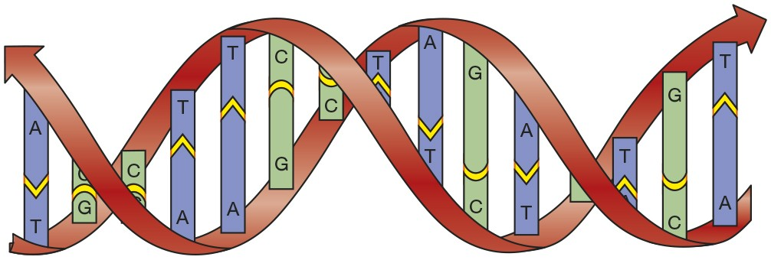

Answer: D
LO/EO: 1.3; 1.3.1
Examine the student-drawn models.
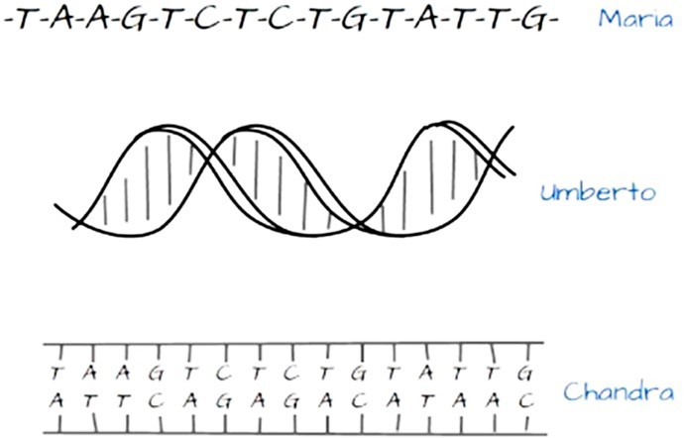
- All three models represent DNA.
Answer: TRUE
LO/EO: 1.3; 1.3.1
- Models must always include all available information to be useful.
Answer: FALSE
LO/EO: 1.3; 1.3.1
- If the goal was to compare the three-dimensional shape of DNA to other molecules, Umberto’s model would be the most helpful.
Answer: TRUE
LO/EO: 1.3; 1.3.1
- If the goal was to show how information is stored in double-stranded DNA, Chandra’s model would be the most helpful.
Answer: TRUE
LO/EO: 1.3; 1.3.1
- If the goal was to compare the DNA sequences of several species, Maria’s model would be the most helpful.
Answer: TRUE
LO/EO: 1.3; 1.3.1
Four students have used different circling strategies to show the differences in DNA sequence between Atlantic salmon and three other species.
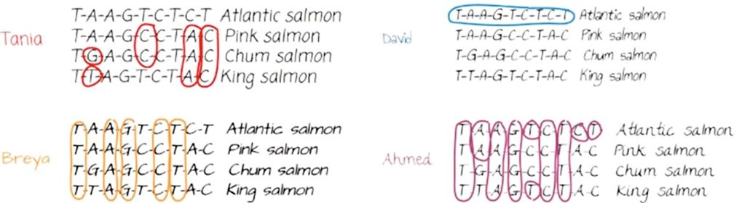
- Refer to the figure above. Whose approach do you think is most helpful in this analysis?
- Ahmed’s approach
- David’s approach
- Tania’s approach
- Breya’s approach
Answer: C
LO/EO: 1.3; 1.3.1
- Based upon the rRNA sequences provided, where should species 2 be placed on the phylogenetic tree provided for the three species?
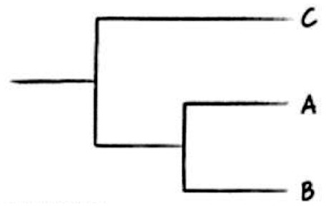
Species 1: A U G U C C A A U G
Species 2: U G G U C A G A U G
Species 3: A C G U C C A A U G
- A
- B
- C
- Either A or B
- Either B or C
Answer: C
Bloom’s Taxonomy: Applying/Analyzing
V&C Core Concept: E
V&C Core Comp: PS
LO/EO: 1.5; 1.5.1, 1.5.2
Section: 1.5

