Student name:__________

**1)** The study of normal body structures is called ___________.

A) physiology   
 B) anatomy  
 C) pathology  
 D) microscopy  
 E) biology

**Question Details**Section : 01.01  
Learning Outcome : 01.01a Define anatomy and physiology and relate them to each other.  
Gradable : automatic  
Accessibility : Keyboard Navigation  
Topic : Scope of anatomy and physiology  
Bloom's : 1. Remember  
Type : Anatomy  
HAPS Topic : Module A05 Basic terminology  
HAPS Outcome : A05.01 Define the terms anatomy and physiology.

**2)** The study of how the body functions is called ___________.

A) neuroanatomy   
 B) anatomy  
 C) chemistry  
 D) histology  
 E) physiology

**Question Details**Section : 01.01  
Bloom's : 2. Understand  
Learning Outcome : 01.01a Define anatomy and physiology and relate them to each other.  
Gradable : automatic  
Accessibility : Keyboard Navigation  
Topic : Scope of anatomy and physiology  
Type : Physiology  
HAPS Topic : Module A05 Basic terminology  
HAPS Outcome : A05.01 Define the terms anatomy and physiology.

**3)** Feeling structures with your fingertips is called __________, whereas tapping on the body and listening for sounds of abnormalities is called __________.

A) palpation;auscultation   
 B) auscultation;percussion  
 C) percussion;auscultation  
 D) palpation;percussion  
 E) percussion;palpation

**Question Details**Section : 01.01  
Learning Outcome : 01.01b Describe several ways of studying human anatomy.  
Bloom's : 2. Understand  
Gradable : automatic  
Accessibility : Keyboard Navigation  
Topic : Scope of anatomy and physiology  
Type : Anatomy  
HAPS Topic : Module A05 Basic terminology

**4)** Which of these is the best imaging technique for routinely examining the anatomical development of a fetus?

A) Auscultation   
 B) PET scan  
 C) MRI  
 D) Sonography  
 E) Radiography

**Question Details**Section : 01.01  
Learning Outcome : 01.01b Describe several ways of studying human anatomy.  
Gradable : automatic  
Accessibility : Keyboard Navigation  
Topic : Scope of anatomy and physiology  
Bloom's : 1. Remember  
Type : Anatomy

**5)** The study of the structure and function of cells is called __________.

A) cytology   
 B) gross anatomy  
 C) exploratoryphysiology  
 D) comparativephysiology  
 E) radiology

**Question Details**Section : 01.01  
Learning Outcome : 01.01b Describe several ways of studying human anatomy.  
Gradable : automatic  
Accessibility : Keyboard Navigation  
Topic : Scope of anatomy and physiology  
Bloom's : 1. Remember  
Type : Anatomy  
Type : Physiology  
HAPS Topic : Module A06 Levels of organization  
HAPS Outcome : A06.01 Describe, in order from simplest to most complex, the major levels of organizat

**6)** Ultrastructure refers to the detailed structure to the level of the ___________.

A) molecule   
 B) cell  
 C) organelle  
 D) tissue  
 E) organ

**Question Details**Section : 01.01  
Learning Outcome : 01.01b Describe several ways of studying human anatomy.  
Bloom's : 2. Understand  
Gradable : automatic  
Accessibility : Keyboard Navigation  
Topic : Scope of anatomy and physiology  
Type : Anatomy  
HAPS Topic : Module A06 Levels of organization  
HAPS Outcome : A06.01 Describe, in order from simplest to most complex, the major levels of organizat

**7)** The study of how hormones function is called ____________.

A) neuroanatomy   
 B) neurophysiology  
 C) endocrinology  
 D) histology  
 E) pathophysiology

**Question Details**Section : 01.01  
Bloom's : 2. Understand  
Learning Outcome : 01.01c Define a few subdisciplines of human physiology.  
Gradable : automatic  
Accessibility : Keyboard Navigation  
Topic : Scope of anatomy and physiology  
Type : Physiology  
HAPS Topic : Module A07 Survey of body systems  
HAPS Outcome : A07.02 Describe the major functions of each organ system.

**8)** The study of mechanism of disease is called __________.

A) neuroanatomy   
 B) neurophysiology  
 C) endocrinology  
 D) histology  
 E) pathophysiology

**Question Details**Section : 01.01  
Bloom's : 2. Understand  
Learning Outcome : 01.01c Define a few subdisciplines of human physiology.  
Gradable : automatic  
Accessibility : Keyboard Navigation  
Topic : Scope of anatomy and physiology  
Type : Physiology  
HAPS Topic : Module A05 Basic terminology

**9)** The terms  *physics, physiology,* and  *physician* come from a term __________ proposed to distinguish natural causes from supernatural causes.

A) Hippocrates   
 B) Plato  
 C) Schwann  
 D) Aristotle  
 E) Avicenna

**Question Details**Section : 01.02  
Learning Outcome : 01.02b Describe the contributions of some key people who helped to bring about thi  
Learning Outcome : 01.02a Give examples of how modern biomedical science emerged from an era of super  
Gradable : automatic  
Accessibility : Keyboard Navigation  
Topic : Origins of biomedical science  
Bloom's : 1. Remember  
Type : Physiology  
HAPS Topic : Module A05 Basic terminology

**10)** Who was a physician to the Roman gladiators, learned by dissection of animals, and saw science as a method of discovery?

A) Hippocrates   
 B) Plato  
 C) Schwann  
 D) Aristotle  
 E) Galen

**Question Details**Section : 01.02  
Learning Outcome : 01.02b Describe the contributions of some key people who helped to bring about thi  
Learning Outcome : 01.02a Give examples of how modern biomedical science emerged from an era of super  
Gradable : automatic  
Accessibility : Keyboard Navigation  
Topic : Origins of biomedical science  
Bloom's : 1. Remember

**11)** Knownas "the father of modern anatomy," __________ was the first to publish accurate drawings of the body.

A) Vesalius   
 B) Maimonides  
 C) Harvey  
 D) Aristotle  
 E) van Leeuwenhoek

**Question Details**Section : 01.02  
Learning Outcome : 01.02b Describe the contributions of some key people who helped to bring about thi  
Gradable : automatic  
Accessibility : Keyboard Navigation  
Topic : Origins of biomedical science  
Bloom's : 1. Remember  
Type : Anatomy

**12)** The most influential medical textbook of the ancient era was written by __________.

A) Hippocrates   
 B) Aristotle  
 C) Galen  
 D) Vesalius  
 E) Avicenna

**Question Details**Section : 01.02  
Learning Outcome : 01.02b Describe the contributions of some key people who helped to bring about thi  
Gradable : automatic  
Accessibility : Keyboard Navigation  
Topic : Origins of biomedical science  
Bloom's : 1. Remember  
Type : Anatomy

**13)** Who established a code of ethics for physicians and is considered the "father of medicine"?

A) Aristotle   
 B) Hippocrates  
 C) Galen  
 D) Vesalius  
 E) Hooke

**Question Details**Section : 01.02  
Learning Outcome : 01.02b Describe the contributions of some key people who helped to bring about thi  
Gradable : automatic  
Accessibility : Keyboard Navigation  
Topic : Origins of biomedical science  
Bloom's : 1. Remember  
Type : Anatomy

**14)** What is the process of using numerous observations to develop general principles and predictions about a specific subject called?

A) Experimental design   
 B) The deductive method  
 C) The inductive method  
 D) A hypothesis  
 E) Statistical testing

**Question Details**Section : 01.03  
Learning Outcome : 01.03a Describe the inductive and hypothetico-deductive methods of obtaining scien  
Bloom's : 2. Understand  
Gradable : automatic  
Accessibility : Keyboard Navigation  
Topic : Scientific Method

**15)** Most people think that ulcers are caused by psychological stress. It was discovered that an acid-resistant bacterium, *Heliobacter pylori*, lives in the lining of the stomach. If these bacteria cause ulcers, then treatment with an antibiotic should reduce ulcers. This line of investigation is an example of __________.

A) hypotheticalreasoning   
 B) hypothetico-deductive reasoning  
 C) the inductivemethod  
 D) experimentaldesign  
 E) statisticalanalysis

**Question Details**Bloom's : 3. Apply  
Section : 01.03  
Learning Outcome : 01.03a Describe the inductive and hypothetico-deductive methods of obtaining scien  
Gradable : automatic  
Accessibility : Keyboard Navigation  
Topic : Scientific Method  
Type : Physiology

**16)** The use of controls and statistical testing are two aspects of experimental design that help to ensure __________.

A) an adequate samplesize   
 B) objective andreliable results  
 C) experimentalbias  
 D) psychosomaticeffects  
 E) treatmentgroups

**Question Details**Bloom's : 3. Apply  
Section : 01.03  
Learning Outcome : 01.03b Describe some aspects of experimental design that help to ensure objective  
Gradable : automatic  
Accessibility : Keyboard Navigation  
Topic : Scientific Method

**17)** Which process submits a scientist's ideas to the critical judgment of other specialists in the field before the research is funded or published?

A) Adjudication   
 B) Statistical testing  
 C) Falsification  
 D) Peer review  
 E) Hypothetico-deductive testing

**Question Details**Section : 01.03  
Learning Outcome : 01.03b Describe some aspects of experimental design that help to ensure objective  
Gradable : automatic  
Accessibility : Keyboard Navigation  
Topic : Scientific Method  
Bloom's : 1. Remember

**18)** A new drug apparently increases short-term memory. Students were divided randomly into two groups at the beginning of the semester. One group was given the memory pill once a day for the semester, and the other group was given a same-looking pill, but it was just sugar. The sugar pill is termed a(n) __________.

A) controlledpill   
 B) placebo  
 C) treatmentpill  
 D) variable  
 E) effectivedose

**Question Details**Bloom's : 3. Apply  
Section : 01.03  
Learning Outcome : 01.03b Describe some aspects of experimental design that help to ensure objective  
Gradable : automatic  
Accessibility : Keyboard Navigation  
Topic : Scientific Method

**19)** Two groups of people were tested to determine whether garlic lowers blood cholesterol levels. One group was given 800 mg of garlic powder daily for four months and exhibited an average 12% reduction in the blood cholesterol. The other group was not given any garlic and after four months averaged a 3% reduction in cholesterol. The group that was not given the garlic was the __________ group.

A) peer   
 B) test  
 C) treatment  
 D) control  
 E) double-blind

**Question Details**Bloom's : 3. Apply  
Section : 01.03  
Learning Outcome : 01.03b Describe some aspects of experimental design that help to ensure objective  
Gradable : automatic  
Accessibility : Keyboard Navigation  
Topic : Scientific Method

**20)** An educated speculation or a possible answer to a question is called a(n) __________.

A) scientificmethod   
 B) theory  
 C) law  
 D) hypothesis  
 E) fact

**Question Details**Section : 01.03  
Bloom's : 2. Understand  
Learning Outcome : 01.03c Explain what is meant by hypothesis, fact, law, and theory in science.  
Gradable : automatic  
Accessibility : Keyboard Navigation  
Topic : Scientific Method  
HAPS Topic : Module A05 Basic terminology

**21)** Which of the following would contain the greatest amount of information that scientists consider to be true to the best of their knowledge?

A) A fact   
 B) A law ofnature  
 C) A hypothesis  
 D) An equation  
 E) A theory

**Question Details**Bloom's : 3. Apply  
Section : 01.03  
Learning Outcome : 01.03c Explain what is meant by hypothesis, fact, law, and theory in science.  
Gradable : automatic  
Accessibility : Keyboard Navigation  
Topic : Scientific Method  
HAPS Topic : Module A05 Basic terminology

**22)** If a species of animal evolves over generations to grow a large fan-blade like growth on its back to catch the wind and cool its body, this would be an example of responding to __________.

A) selection pressure   
 B) adaptation  
 C) natural selection  
 D) climate change  
 E) positive feedback

**Question Details**Bloom's : 3. Apply  
Section : 01.04  
Learning Outcome : 01.04a Explain why evolution is relevant to understanding human form and function.  
Gradable : automatic  
Accessibility : Keyboard Navigation  
Topic : Human origins and adaptations

**23)** What is a change in the genetic composition of a population over time called?

A) Mutation   
 B) Natural selection  
 C) Selection pressure  
 D) Evolution  
 E) Adaptation

**Question Details**Section : 01.04  
Learning Outcome : 01.04b Define evolution and natural selection.  
Gradable : automatic  
Accessibility : Keyboard Navigation  
Topic : Human origins and adaptations  
Bloom's : 1. Remember

**24)** The constant appearance of new strains of influenza virus is an example of __________.

A) a model   
 B) evolution  
 C) selectionpressure  
 D) survivorship  
 E) success

**Question Details**Bloom's : 3. Apply  
Section : 01.04  
Learning Outcome : 01.04b Define evolution and natural selection.  
Gradable : automatic  
Accessibility : Keyboard Navigation  
Topic : Human origins and adaptations

**25)** What is the principal theory of how evolution works?

A) Natural pressure   
 B) Selective pressure  
 C) Darwinian pressure  
 D) Natural adaptation  
 E) Natural selection

**Question Details**Section : 01.04  
Learning Outcome : 01.04b Define evolution and natural selection.  
Gradable : automatic  
Accessibility : Keyboard Navigation  
Topic : Human origins and adaptations  
Bloom's : 1. Remember

**26)** Stereoscopic vision provides __________.

A) opposableperception   
 B) colorperception  
 C) depthperception  
 D) bipedalism  
 E) opposition of thumbs

**Question Details**Section : 01.04  
Learning Outcome : 01.04c Describe some human characteristics that can be attributed to the tree-dwel  
Gradable : automatic  
Accessibility : Keyboard Navigation  
Topic : Human origins and adaptations  
Bloom's : 1. Remember  
Type : Anatomy

**27)** Most primates are __________, meaning they live in trees.

A) prehensile   
 B) bipedal  
 C) cursorial  
 D) troglodytic  
 E) arboreal

**Question Details**Section : 01.04  
Learning Outcome : 01.04c Describe some human characteristics that can be attributed to the tree-dwel  
Gradable : automatic  
Accessibility : Keyboard Navigation  
Topic : Human origins and adaptations  
Bloom's : 1. Remember

**28)** Which of the following was an adaptation thatevolved in connection with human upright walking?

A) Hair   
 B) Fully opposablethumbs  
 C) Stereoscopicvision  
 D) Color vision  
 E) Spinal and pelvicanatomy

**Question Details**Bloom's : 2. Understand  
Section : 01.04  
Learning Outcome : 01.04d Describe some human characteristics that evolved later in connection with u  
Gradable : automatic  
Accessibility : Keyboard Navigation  
Topic : Human origins and adaptations

**29)** A human is born before his/her nervous system has matured. This is traceable to __________.

A) their inabilityto regulate body temperature   
 B) skeletaladaptations to bipedalism  
 C) the arborealhabits of early primates  
 D) the conditions ofmodern civilization  
 E) the diet of earlyspecies of Homo

**Question Details**Bloom's : 2. Understand  
Section : 01.04  
Learning Outcome : 01.04d Describe some human characteristics that evolved later in connection with u  
Gradable : automatic  
Accessibility : Keyboard Navigation  
Topic : Human origins and adaptations  
Type : Physiology

**30)** What is the species of modern humans?

A) *Homo erectus*   
 B) *Homo sapiens*  
 C) *Homo habilis*  
 D) *Neanderthal*  
 E) *Australopithecus*

**Question Details**Section : 01.04  
Learning Outcome : 01.04d Describe some human characteristics that evolved later in connection with u  
Gradable : automatic  
Accessibility : Keyboard Navigation  
Topic : Human origins and adaptations  
Bloom's : 1. Remember

**31)** An __________ is composed of two or more tissues types, whereas __________ are microscopic structures in a cell.

A) organ system;organs   
 B) organ system;organelles  
 C) organ;organelles  
 D) organ;molecules  
 E) organelle;molecules

**Question Details**Bloom's : 2. Understand  
Section : 01.05  
Learning Outcome : 01.05a List the levels of human structure from the most complex to the simplest.  
Gradable : automatic  
Accessibility : Keyboard Navigation  
Topic : Scope of anatomy and physiology  
Type : Anatomy  
HAPS Topic : Module A06 Levels of organization  
HAPS Outcome : A06.01 Describe, in order from simplest to most complex, the major levels of organizat

**32)** Which of the following lists levels of human structure from the *most complex to the simplest*?

A) Organelle, cell,tissue, organ, organ system   
 B) Organ system,organ, cell, tissue, organelle  
 C) Organ system,organelle, tissue, cell, organ  
 D) Organ system,organ, tissue, cell, organelle  
 E) Organ, organsystem, tissue, cell, organelle

**Question Details**Bloom's : 2. Understand  
Section : 01.05  
Learning Outcome : 01.05a List the levels of human structure from the most complex to the simplest.  
Gradable : automatic  
Accessibility : Keyboard Navigation  
Topic : Scope of anatomy and physiology  
Type : Anatomy  
HAPS Topic : Module A06 Levels of organization  
HAPS Outcome : A06.01 Describe, in order from simplest to most complex, the major levels of organizat

**33)** Which of the followinglists examples of body structures from the *simplest to the most complex*?

A) Mitochondrion,connective tissue, protein, stomach, adipocyte (fat cell)   
 B) Protein,mitochondrion, adipocyte (fat cell), connective tissue, stomach  
 C) Mitochondrion,connective tissue, stomach, protein, adipocyte (fat cell)  
 D) Protein,adipocyte (fat cell), stomach, connective tissue, mitochondrion  
 E) Protein, stomach,connective tissue, adipocyte (fat cell), mitochondrion

**Question Details**Bloom's : 3. Apply  
Section : 01.05  
Learning Outcome : 01.05a List the levels of human structure from the most complex to the simplest.  
Gradable : automatic  
Accessibility : Keyboard Navigation  
Topic : Scope of anatomy and physiology  
Type : Anatomy  
HAPS Topic : Module A06 Levels of organization  
HAPS Outcome : A06.01 Describe, in order from simplest to most complex, the major levels of organizat

**34)** A(n) __________ is a group of similar cells and their intercellular materials in a discrete region of an organ performing a specific function.

A) macromolecule   
 B) organ system  
 C) organelle  
 D) organism  
 E) tissue

**Question Details**Section : 01.05  
Learning Outcome : 01.05a List the levels of human structure from the most complex to the simplest.  
Gradable : automatic  
Accessibility : Keyboard Navigation  
Topic : Scope of anatomy and physiology  
Bloom's : 1. Remember  
Type : Anatomy  
HAPS Topic : Module A06 Levels of organization  
HAPS Outcome : A06.01 Describe, in order from simplest to most complex, the major levels of organizat

**35)** All of the following are human organ systems *except __________.*

A) skeletal   
 B) endocrine  
 C) epidermal  
 D) reproductive  
 E) lymphatic

**Question Details**Bloom's : 3. Apply  
Section : 01.05  
Learning Outcome : 01.05a List the levels of human structure from the most complex to the simplest.  
Gradable : automatic  
Accessibility : Keyboard Navigation  
Topic : Scope of anatomy and physiology  
Type : Anatomy  
HAPS Topic : Module A07 Survey of body systems  
HAPS Outcome : A07.01 List the organ systems of the human body and their major components.

**36)** All of the following are organs *except __________.*

A) teeth   
 B) the skin  
 C) nails  
 D) the liver  
 E) the digestivesystem

**Question Details**Bloom's : 2. Understand  
Section : 01.05  
Learning Outcome : 01.05a List the levels of human structure from the most complex to the simplest.  
Gradable : automatic  
Accessibility : Keyboard Navigation  
Topic : Scope of anatomy and physiology  
Type : Anatomy  
HAPS Topic : Module A06 Levels of organization  
HAPS Outcome : A06.02 Give an example of each level of organization.

**37)** Taking apart a clock to see how it works is similar to __________ thinking about human physiology.

A) comparative   
 B) evolutionary  
 C) holistic  
 D) inductive  
 E) reductionist

**Question Details**Bloom's : 3. Apply  
Section : 01.05  
Learning Outcome : 01.05b Discuss the value of both reductionistic and holistic viewpoints to underst  
Gradable : automatic  
Accessibility : Keyboard Navigation  
Topic : Scope of anatomy and physiology  
Type : Physiology  
HAPS Topic : Module A05 Basic terminology  
HAPS Outcome : A05.01 Define the terms anatomy and physiology.

**38)** Which of the following approaches understanding the human body by studying the interactions of its parts?

A) Naturalism   
 B) Reductionism  
 C) Vitalism  
 D) Holism  
 E) Rationalism

**Question Details**Section : 01.05  
Learning Outcome : 01.05b Discuss the value of both reductionistic and holistic viewpoints to underst  
Gradable : automatic  
Accessibility : Keyboard Navigation  
Topic : Scope of anatomy and physiology  
Bloom's : 1. Remember  
Type : Physiology

**39)** What is the view that not everything about an organism can be understood or predicted from the knowledge of its components; that is, the whole is greater than the sum of its parts?

A) Naturalism   
 B) Reductionism  
 C) Holism  
 D) Materialism  
 E) Science

**Question Details**Section : 01.05  
Learning Outcome : 01.05b Discuss the value of both reductionistic and holistic viewpoints to underst  
Gradable : automatic  
Accessibility : Keyboard Navigation  
Topic : Scope of anatomy and physiology  
Bloom's : 1. Remember  
Type : Physiology

**40)** The fact that most of us have five lumbar vertebrae, but some people have six and some have four, is an example of what type of variation among organisms?

A) Cellular   
 B) Holistic  
 C) Physiological  
 D) Anatomical  
 E) Reductionist

**Question Details**Bloom's : 3. Apply  
Section : 01.05  
Learning Outcome : 01.05c Discuss the clinical significance of anatomical variation among humans.  
Gradable : automatic  
Accessibility : Keyboard Navigation  
Topic : Scope of anatomy and physiology  
Type : Anatomy  
HAPS Topic : Module A05 Basic terminology

**41)** Why does a surgeon need to be familiar with different versions of anatomy?

A) Cellular adaptation   
 B) Holistic medicine  
 C) Physiological variation  
 D) Anatomical variation  
 E) Evolutionary adaptation

**Question Details**Bloom's : 3. Apply  
Section : 01.05  
Learning Outcome : 01.05c Discuss the clinical significance of anatomical variation among humans.  
Gradable : automatic  
Accessibility : Keyboard Navigation  
Topic : Scope of anatomy and physiology  
Type : Anatomy

**42)** What are the simplest body structures considered alive?

A) Organ systems   
 B) Organs  
 C) Cells  
 D) Organelles  
 E) Molecules

**Question Details**Section : 01.05  
Learning Outcome : 01.06a State the characteristics that distinguish living organisms from nonliving  
Gradable : automatic  
Accessibility : Keyboard Navigation  
Topic : Scope of anatomy and physiology  
Bloom's : 1. Remember  
Type : Anatomy  
HAPS Topic : Module A06 Levels of organization  
HAPS Outcome : A06.01 Describe, in order from simplest to most complex, the major levels of organizat

**43)** Metabolism is the sum of all __________ change.

A) external physical   
 B) external chemical  
 C) internal chemical  
 D) internal physical  
 E) internal integrative

**Question Details**Section : 01.06  
Learning Outcome : 01.06a State the characteristics that distinguish living organisms from nonliving  
Gradable : automatic  
Accessibility : Keyboard Navigation  
Topic : Scope of anatomy and physiology  
Bloom's : 1. Remember  
Type : Physiology  
HAPS Topic : Module A06 Levels of organization  
HAPS Outcome : A06.02 Give an example of each level of organization.

**44)** The change in size of the bone marrow (where blood cells are produced) as an infant matures is an example of __________, whereas the transformation of blood stem cells into white blood cells is an example of __________.

A) development;differentiation   
 B) growth;development  
 C) growth;differentiation  
 D) differentiation;growth  
 E) differentiation;development

**Question Details**Bloom's : 3. Apply  
Section : 01.06  
Learning Outcome : 01.06a State the characteristics that distinguish living organisms from nonliving  
Gradable : automatic  
Accessibility : Keyboard Navigation  
Topic : Scope of anatomy and physiology  
Type : Physiology

**45)** A hemoglobin level of 12g/dL is normal for an adult female, but low for an adult male. What is this is an example of?

A) Cellular adaptation   
 B) Holistic medicine  
 C) Physiological variation  
 D) Anatomical variation  
 E) Structural differentiation

**Question Details**Bloom's : 3. Apply  
Section : 01.06  
Learning Outcome : 01.06b Explain the importance of physiological variation among persons  
Gradable : automatic  
Accessibility : Keyboard Navigation  
Topic : Scope of anatomy and physiology  
Type : Physiology

**46)** Which of the following is *not* an aspectthat could result in physiological variation?

A) Age   
 B) Gender  
 C) Environment  
 D) Physicalactivity  
 E) These are allaspects that can cause physiological variation.

**Question Details**Bloom's : 3. Apply  
Section : 01.06  
Learning Outcome : 01.06b Explain the importance of physiological variation among persons  
Gradable : automatic  
Accessibility : Keyboard Navigation  
Topic : Scope of anatomy and physiology  
Type : Physiology

**47)** We live in an ever-changing environment outside of our body, yet our internal conditions remain relatively stable. This is called __________.

A) homeostasis   
 B) metastasis  
 C) responsiveness  
 D) adaptation  
 E) evolution

**Question Details**Bloom's : 2. Understand  
Section : 01.06  
Learning Outcome : 01.06c Define homeostasis and explain why this concept is central to physiology.  
Gradable : automatic  
Accessibility : Keyboard Navigation  
Topic : Definition of homeostasis  
Type : Physiology  
HAPS Topic : Module B01 Definition of Homeostasis  
HAPS Outcome : B01.01 Define homeostasis.

**48)** What are the three common components of a feedback loop?

A) Stimulus, integrating (control) center, and organ system   
 B) Stimulus, receptor, and integrating (control) center  
 C) Receptor, integrating (control) center, and effector  
 D) Receptor, organ, and organ system  
 E) Receptor, integrating (control) center, and organ system

**Question Details**Bloom's : 2. Understand  
Section : 01.06  
Learning Outcome : 01.06c Define homeostasis and explain why this concept is central to physiology.  
Gradable : automatic  
Accessibility : Keyboard Navigation  
Topic : Types of homeostatic mechanisms  
Type : Physiology  
HAPS Topic : Module B02 General types of homeostatic mechanisms  
HAPS Outcome : B02.02 List the steps in a feedback mechanism (loop) and explain the function of each

**49)** During exercise, one generates excess heat and the body temperature rises. As a response, blood vessels dilate in the skin, warm blood flows closer to the body surface, and heat is lost. This is an example of__________.

A) negativefeedback   
 B) positivefeedback  
 C) dynamicequilibrium  
 D) integrationcontrol  
 E) set pointadjustment

**Question Details**Bloom's : 3. Apply  
Section : 01.06  
Learning Outcome : 01.06d Define negative feedback, give an example of it, and explain its importance  
Gradable : automatic  
Accessibility : Keyboard Navigation  
Topic : Examples of homeostatic mechanisms  
Type : Physiology  
HAPS Topic : Module B02 General types of homeostatic mechanisms  
HAPS Outcome : B02.03 Compare and contrast positive and negative feedback in terms of the relationshi

**50)** Blood glucose concentration rises after a meal and stimulates the pancreas to release the hormone insulin. Insulin travels in the blood and stimulates the uptake ofglucose by body cells from the bloodstream, thusreducing blood glucose concentration. This is an example of _________.

A) negativefeedback   
 B) positivefeedback  
 C) dynamicequilibrium  
 D) integrationcontrol  
 E) set pointadjustment

**Question Details**Bloom's : 3. Apply  
Section : 01.06  
Learning Outcome : 01.06d Define negative feedback, give an example of it, and explain its importance  
Gradable : automatic  
Accessibility : Keyboard Navigation  
Topic : Examples of homeostatic mechanisms  
Type : Physiology  
HAPS Topic : Module B02 General types of homeostatic mechanisms  
HAPS Outcome : B02.03 Compare and contrast positive and negative feedback in terms of the relationshi

**51)** Negative feedback loops are __________.

A) homeostaticmechanisms   
 B) not homeostaticmechanisms  
 C) associated with"vicious circles"  
 D) self-amplifyingcycles  
 E) usually harmful

**Question Details**Section : 01.06  
Learning Outcome : 01.06d Define negative feedback, give an example of it, and explain its importance  
Gradable : automatic  
Accessibility : Keyboard Navigation  
Topic : Types of homeostatic mechanisms  
Bloom's : 1. Remember  
Type : Physiology  
HAPS Topic : Module B02 General types of homeostatic mechanisms  
HAPS Outcome : B02.03 Compare and contrast positive and negative feedback in terms of the relationshi

**52)** When a woman is giving birth, the head of the baby pushes against her cervix and stimulates therelease of the hormone oxytocin. Oxytocin travels in the blood and stimulates the uterus to contract. Labor contractions become more and more intense until the baby is expelled. This is an example of __________.

A) negativefeedback   
 B) positivefeedback  
 C) dynamicequilibrium  
 D) integrationcontrol  
 E) set pointadjustment

**Question Details**Bloom's : 3. Apply  
Section : 01.06  
Learning Outcome : 01.06e Define positive feedback and give examples of its beneficial and harmful ef  
Gradable : automatic  
Accessibility : Keyboard Navigation  
Topic : Examples of homeostatic mechanisms  
Type : Physiology  
HAPS Topic : Module B02 General types of homeostatic mechanisms  
HAPS Outcome : B02.03 Compare and contrast positive and negative feedback in terms of the relationshi

**53)** Which of the following is *most likely* to cause disease?

A) Positivefeedback   
 B) Negativefeedback  
 C) Homeostasis  
 D) Equilibrium  
 E) Irritability

**Question Details**Bloom's : 2. Understand  
Section : 01.06  
Learning Outcome : 01.06e Define positive feedback and give examples of its beneficial and harmful ef  
Gradable : automatic  
Accessibility : Keyboard Navigation  
Topic : Types of homeostatic mechanisms  
Type : Physiology  
HAPS Topic : Module B02 General types of homeostatic mechanisms  
HAPS Outcome : B02.03 Compare and contrast positive and negative feedback in terms of the relationshi

**54)** A physiological __________ is a difference in chemical concentration, electrical charge, physical pressure, temperature, or other variables between one point and another.

A) gradient   
 B) barrier  
 C) membrane  
 D) imbalance  
 E) feedback loop

**Question Details**Section : 01.06  
Learning Outcome : 01.06f Define gradient, describe the variety of gradients in human physiology, and  
Gradable : automatic  
Accessibility : Keyboard Navigation  
Topic : Scope of anatomy and physiology  
Bloom's : 1. Remember  
Type : Physiology

**55)** Chemicals in a solution can move down a concentration gradient. This means the chemical will move from the area of__________ concentrationto the area of_________ concentration.

A) higher; lower   
 B) lower; higher  
 C) equal; equal  
 D) lower; lower  
 E) higher; higher

**Question Details**Bloom's : 2. Understand  
Section : 01.06  
Learning Outcome : 01.06f Define gradient, describe the variety of gradients in human physiology, and  
Gradable : automatic  
Accessibility : Keyboard Navigation  
Topic : Scope of anatomy and physiology  
Type : Physiology

**56)** Which of the following is *not* an example of a physiological gradient?

A) Tissue   
 B) Thermal  
 C) Concentration  
 D) Pressure  
 E) Electrical

**Question Details**Bloom's : 2. Understand  
Section : 01.06  
Learning Outcome : 01.06f Define gradient, describe the variety of gradients in human physiology, and  
Gradable : automatic  
Accessibility : Keyboard Navigation  
Topic : Scope of anatomy and physiology  
Type : Physiology

**57)** What type of gradient causes the movement of ions due to *both charge and concentration* differences?

A) Electrochemical gradient   
 B) Thermal gradient  
 C) Concentration gradient  
 D) Pressure gradient  
 E) Osmotic gradient

**Question Details**Bloom's : 3. Apply  
Section : 01.06  
Learning Outcome : 01.06f Define gradient, describe the variety of gradients in human physiology, and  
Gradable : automatic  
Accessibility : Keyboard Navigation  
Topic : Scope of anatomy and physiology  
Type : Physiology

**58)** Modern anatomical language is based on what two languages because individuals speaking these languages made most of the early anatomical discoveries?

A) Greek and Latin   
 B) English and Japanese  
 C) English and Spanish  
 D) Roman and Latin  
 E) Latin and Chinese

**Question Details**Section : 01.07  
Learning Outcome : 01.07a Explain why modern anatomical terminology is so heavily based on Greek and  
Learning Outcome : 01.07c Describe the efforts to achieve an internationally uniform anatomical termi  
Gradable : automatic  
Accessibility : Keyboard Navigation  
Topic : Scope of anatomy and physiology  
Bloom's : 1. Remember  
Type : Anatomy  
HAPS Topic : Module A05 Basic terminology

**59)** The term *fallopian* tube (uterine tube) is an example of __________.

A) a Latin root usedin medical terminology   
 B) the use ofprefixes to name an anatomical structure  
 C) the use ofsuffixes to name an anatomical structure  
 D) an eponym  
 E) an acronym

**Question Details**Section : 01.07  
Learning Outcome : 01.07b Recognize eponyms when you see them.  
Gradable : automatic  
Accessibility : Keyboard Navigation  
Topic : Scope of anatomy and physiology  
Bloom's : 1. Remember  
Type : Anatomy  
HAPS Topic : Module A05 Basic terminology

**60)** The lexicon of standard international anatomical terms is __________.

A) called *Terminologia Anatomica* (TA)   
 B) called *Nomina Anatomica* (NA)  
 C) formed fromthousands of English word roots  
 D) formed fromthousands of Italian word roots  
 E) formed fromthousands of French word roots

**Question Details**Section : 01.07  
Learning Outcome : 01.07c Describe the efforts to achieve an internationally uniform anatomical termi  
Gradable : automatic  
Accessibility : Keyboard Navigation  
Topic : Scope of anatomy and physiology  
Bloom's : 1. Remember  
Type : Anatomy  
HAPS Topic : Module A05 Basic terminology

**61)** The prefix *hypo-* means __________, whereas *hyper-* means __________.

A) front; back   
 B) right; left  
 C) inside;outside  
 D) clear; dark  
 E) below; above

**Question Details**Section : 01.07  
Learning Outcome : 01.07d Break medical terms down into their basic word elements.  
Gradable : automatic  
Accessibility : Keyboard Navigation  
Topic : Scope of anatomy and physiology  
Bloom's : 1. Remember  
Type : Anatomy  
HAPS Topic : Module A05 Basic terminology

**62)** What does "hypercalcemia" mean?

A) Elevated calcium levels   
 B) Lowered calcium levels  
 C) Elevated sodium levels  
 D) Lowered sodium levels  
 E) Elevated potassium levels

**Question Details**Bloom's : 2. Understand  
Section : 01.07  
Learning Outcome : 01.07d Break medical terms down into their basic word elements.  
Gradable : automatic  
Accessibility : Keyboard Navigation  
Topic : Scope of anatomy and physiology  
Type : Physiology  
HAPS Topic : Module A05 Basic terminology

**63)** DNA is an example of an __________, whereas PET scan is an example of an __________.

A) abbreviation;acronym   
 B) acronym;abbreviation  
 C) eponym;acronym  
 D) acronym;eponym  
 E) eponym;abbreviation

**Question Details**Bloom's : 3. Apply  
Section : 01.07  
Learning Outcome : 01.07e State some reasons why the literal meaning of a word may not lend to insigh  
Gradable : automatic  
Accessibility : Keyboard Navigation  
Topic : Scope of anatomy and physiology  
Type : Anatomy  
HAPS Topic : Module A05 Basic terminology

**64)** The plural of axilla (armpit) is __________, whereas the plural of appendix is __________.

A) axillae;appendices   
 B) axillides;appendages  
 C) axillies;appendi  
 D) axilli;appendices  
 E) axilles; appendices

**Question Details**Bloom's : 2. Understand  
Section : 01.07  
Learning Outcome : 01.07f Relate singular noun forms to their plural and adjectival forms.  
Gradable : automatic  
Accessibility : Keyboard Navigation  
Topic : Scope of anatomy and physiology  
Type : Anatomy  
HAPS Topic : Module A05 Basic terminology

**65)** The plural of villus (hair) is __________, whereas the plural of diagnosis is __________.

A) villuses;diagnosises   
 B) villi;diagnoses  
 C) villus;diagnosis  
 D) villi;diagnosis  
 E) villuses;diagnosis

**Question Details**Bloom's : 2. Understand  
Section : 01.07  
Learning Outcome : 01.07f Relate singular noun forms to their plural and adjectival forms.  
Gradable : automatic  
Accessibility : Keyboard Navigation  
Topic : Scope of anatomy and physiology  
Type : Anatomy  
HAPS Topic : Module A05 Basic terminology

**66)** Why is precise spelling important in anatomy?

A) It is important to practice language skills.   
 B) There are many different ways to spell certain terms.  
 C) Eponyms are difficult to memorize.  
 D) There are many similar terms in anatomy that refer to different structures.  
 E) It is easier to remember acronyms when spelled correctly.

**Question Details**Bloom's : 2. Understand  
Section : 01.07  
Learning Outcome : 01.07g Discuss why precise spelling is important in anatomy and physiology  
Gradable : automatic  
Accessibility : Keyboard Navigation  
Topic : Scope of anatomy and physiology  
Type : Anatomy  
HAPS Topic : Module A05 Basic terminology

**67)** The ileum is __________, whereasthe ilium is ____________.

A) part of the hip bone; part of the small intestine   
 B) part of the smallintestine; part of the hip bone  
 C) a bone in thewrist; a muscle of the back  
 D) a muscle; abone  
 E) a bone; amuscle

**Question Details**Bloom's : 2. Understand  
Section : 01.07  
Learning Outcome : 01.07g Discuss why precise spelling is important in anatomy and physiology  
Gradable : automatic  
Accessibility : Keyboard Navigation  
Topic : Scope of anatomy and physiology  
Type : Anatomy  
HAPS Topic : Module A05 Basic terminology

**68)** What is the name of the highlighted organ?   
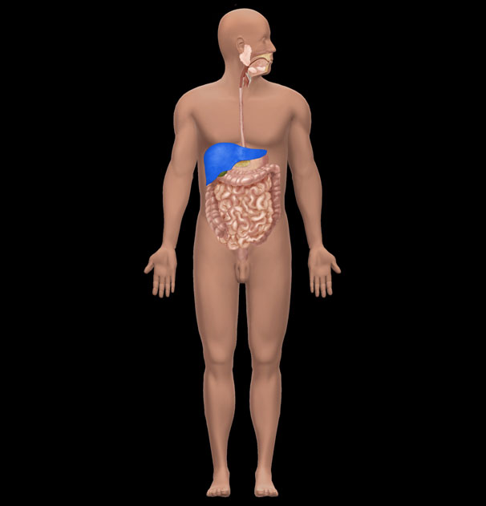

A) Small intestine   
 B) Stomach  
 C) Liver  
 D) Largeintestine  
 E) Spleen

**Question Details**Section : 01.05  
Learning Outcome : 01.05a List the levels of human structure from the most complex to the simplest.  
Gradable : automatic  
Bloom's : 1. Remember  
Type : New  
Type : Anatomy  
HAPS Topic : Module A06 Levels of organization  
HAPS Outcome : A06.02 Give an example of each level of organization.  
Topic : Body Orientation  
Source : APR

**69)** What is the name of the highlighted organ?   
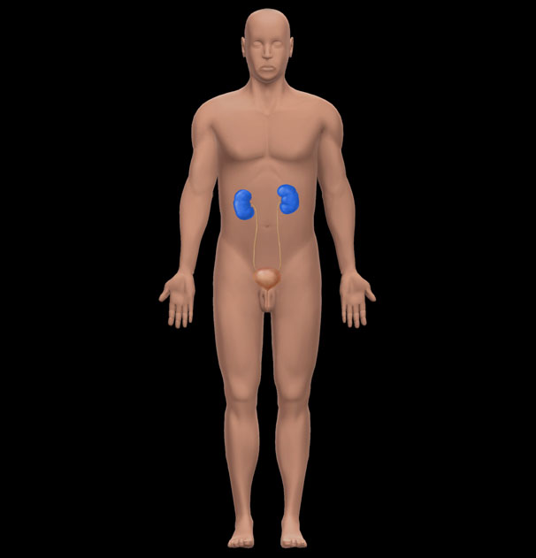

A) Adrenal gland   
 B) Spleen  
 C) Liver  
 D) Kidney  
 E) Pancreas

**Question Details**Section : 01.05  
Learning Outcome : 01.05a List the levels of human structure from the most complex to the simplest.  
Gradable : automatic  
Bloom's : 1. Remember  
Type : New  
Type : Anatomy  
HAPS Topic : Module A06 Levels of organization  
HAPS Outcome : A06.02 Give an example of each level of organization.  
Topic : Body Orientation  
Source : APR

**70)** 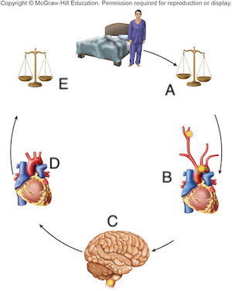

**Question Details**Type : New  
Type : Physiology  
Figure : 01.08

**70.1)** Which letter represents the *receptor* of this feedback loop?

A) A   
 B) B  
 C) C  
 D) D  
 E) E

**Question Details**Bloom's : 2. Understand  
Section : 01.06  
Learning Outcome : 01.06d Define negative feedback, give an example of it, and explain its importance  
Topic : Types of homeostatic mechanisms  
Type : New  
Type : Physiology  
HAPS Topic : Module B02 General types of homeostatic mechanisms  
HAPS Outcome : B02.02 List the steps in a feedback mechanism (loop) and explain the function of each  
Figure : 01.08

**70.2)** Which letter represents the *effector*of this feedback loop?

A) A   
 B) B  
 C) C  
 D) D  
 E) E

**Question Details**Bloom's : 2. Understand  
Section : 01.06  
Learning Outcome : 01.06d Define negative feedback, give an example of it, and explain its importance  
Topic : Types of homeostatic mechanisms  
Type : New  
Type : Physiology  
HAPS Topic : Module B02 General types of homeostatic mechanisms  
HAPS Outcome : B02.02 List the steps in a feedback mechanism (loop) and explain the function of each  
Figure : 01.08

**70.3)** Where in this feedback loop is homeostasis present?

A) A   
 B) B  
 C) C  
 D) D  
 E) E

**Question Details**Bloom's : 2. Understand  
Section : 01.06  
Learning Outcome : 01.06d Define negative feedback, give an example of it, and explain its importance  
Topic : Types of homeostatic mechanisms  
Type : New  
Type : Physiology  
HAPS Topic : Module B02 General types of homeostatic mechanisms  
HAPS Outcome : B02.02 List the steps in a feedback mechanism (loop) and explain the function of each  
Figure : 01.08

**70.4)** This feedback loop is an example of which of the following?

A) Negative feedback   
 B) Positive feedback  
 C) Dynamic equilibrium  
 D) Thermal gradient  
 E) Natural selection

**Question Details**Bloom's : 2. Understand  
Section : 01.06  
Learning Outcome : 01.06d Define negative feedback, give an example of it, and explain its importance  
Topic : Types of homeostatic mechanisms  
Type : New  
Type : Physiology  
HAPS Topic : Module B02 General types of homeostatic mechanisms  
HAPS Outcome : B02.02 List the steps in a feedback mechanism (loop) and explain the function of each  
Figure : 01.08

**71)** 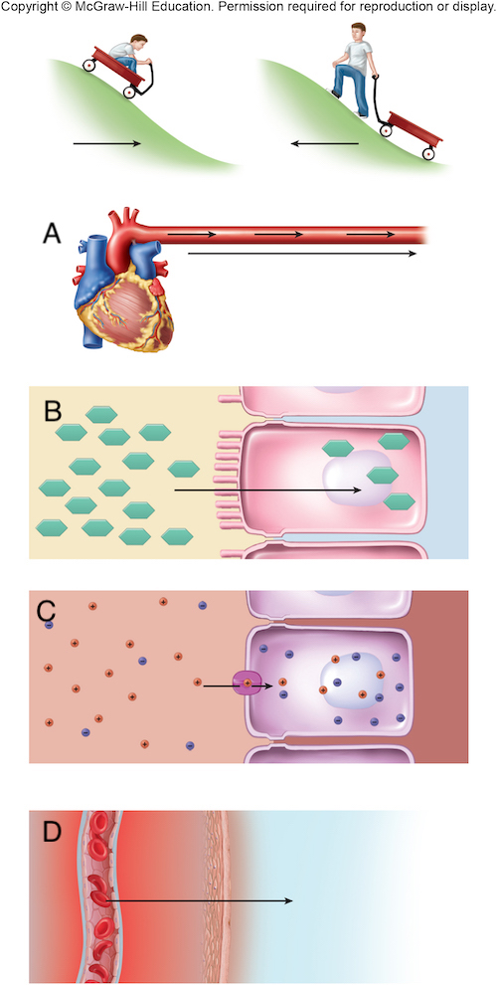

**Question Details**Section : 01.06  
Learning Outcome : 01.06f Define gradient, describe the variety of gradients in human physiology, and  
Bloom's : 1. Remember  
Type : New  
Type : Physiology  
Figure : 01.10

**71.1)** Which letter represents a *pressure*gradient?

A) A   
 B) B  
 C) C  
 D) D  
 E) All of these represent a pressure gradient.

**Question Details**Section : 01.06  
Learning Outcome : 01.06f Define gradient, describe the variety of gradients in human physiology, and  
Bloom's : 1. Remember  
Type : New  
Type : Physiology  
Figure : 01.10

**71.2)** Which letter represents a *thermal*gradient?

A) A   
 B) B  
 C) C  
 D) D  
 E) All of these represent a thermal gradient.

**Question Details**Section : 01.06  
Learning Outcome : 01.06f Define gradient, describe the variety of gradients in human physiology, and  
Bloom's : 1. Remember  
Type : New  
Type : Physiology  
Figure : 01.10

**71.3)** Which picture depicts glucose flowing down a chemical gradient into an intestinal cell?

A) A   
 B) B  
 C) C  
 D) D  
 E) Glucose can move via all of these mechanisms.

**Question Details**Bloom's : 3. Apply  
Section : 01.06  
Learning Outcome : 01.06f Define gradient, describe the variety of gradients in human physiology, and  
Type : New  
Type : Physiology  
Figure : 01.10

**71.4)** Ions would move down which of these gradients?

A) A   
 B) B  
 C) C  
 D) D  
 E) Ions can move via all of these mechanisms.

**Question Details**Bloom's : 3. Apply  
Section : 01.06  
Learning Outcome : 01.06f Define gradient, describe the variety of gradients in human physiology, and  
Type : New  
Type : Physiology  
Figure : 01.10

**72)** 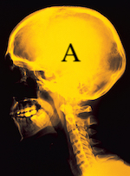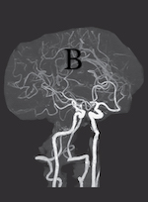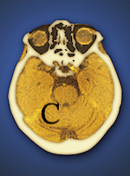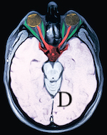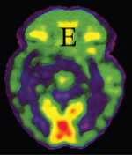  
 a: U.H.B. Trust/The Image Bank/Getty Images; b: pang_oasis/Shutterstock; c: Miriam Maslo/Science  
 Source; d: UHB Trust/Getty Images; e: ISM/Sovereign/Medical Images

**Question Details**Type : New  
Type : Anatomy  
Activity Type : Clinical Application  
Figure : 01.11

**72.1)** Which image is produced using an X-ray?

A) A   
 B) B  
 C) C  
 D) D  
 E) E

**Question Details**Section : 01.07  
Bloom's : 1. Remember  
Type : New  
Type : Anatomy  
Activity Type : Clinical Application  
Figure : 01.11

**72.2)** Which image is produced using Computed Tomography?

A) A   
 B) B  
 C) C  
 D) D  
 E) E

**Question Details**Section : 01.07  
Bloom's : 1. Remember  
Type : New  
Type : Anatomy  
Activity Type : Clinical Application  
Figure : 01.11

**72.3)** Which image is produced using Magnetic Resonance Imaging?

A) A   
 B) B  
 C) C  
 D) D  
 E) E

**Question Details**Section : 01.07  
Bloom's : 1. Remember  
Type : New  
Type : Anatomy  
Activity Type : Clinical Application  
Figure : 01.11

**72.4)** Which imaging technique would be used to determine the location of a blocked artery?

A) A   
 B) B  
 C) C  
 D) D  
 E) E

**Question Details**Bloom's : 3. Apply  
Section : 01.07  
Type : New  
Type : Anatomy  
Activity Type : Clinical Application  
Figure : 01.11

**72.5)** Which imaging technique would be used to determine the metabolically active areas of the brain?

A) A   
 B) B  
 C) C  
 D) D  
 E) E

**Question Details**Bloom's : 3. Apply  
Section : 01.07  
Type : New  
Type : Anatomy  
Activity Type : Clinical Application  
Figure : 01.11

**73)** 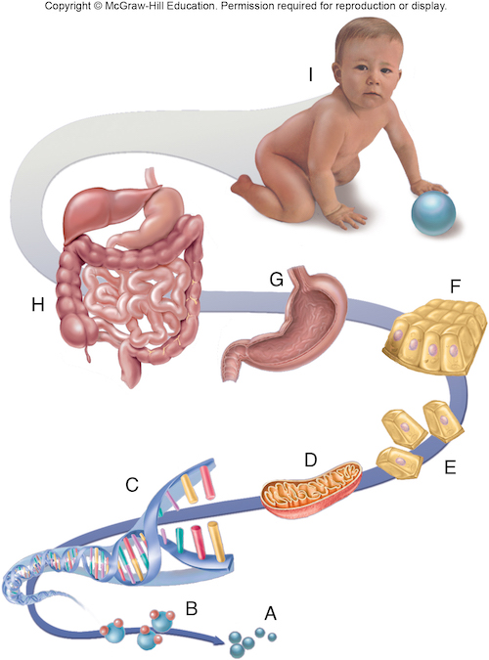

**Question Details**Section : 01.05  
Learning Outcome : 01.05a List the levels of human structure from the most complex to the simplest.  
Type : New  
Type : Anatomy  
HAPS Topic : Module A06 Levels of organization  
HAPS Outcome : A06.01 Describe, in order from simplest to most complex, the major levels of organizat  
Topic : Body Orientation  
Figure : 01.05

**73.1)** What level of structural hierarchy is represented by the letter E?

A) Organelle   
 B) Cell  
 C) Tissue  
 D) Organ  
 E) Molecule

**Question Details**Section : 01.05  
Learning Outcome : 01.05a List the levels of human structure from the most complex to the simplest.  
Bloom's : 1. Remember  
Type : New  
Type : Anatomy  
HAPS Topic : Module A06 Levels of organization  
HAPS Outcome : A06.01 Describe, in order from simplest to most complex, the major levels of organizat  
Topic : Body Orientation  
Figure : 01.05

**73.2)** What level of structural hierarchy is represented by the letter H?

A) Organ system   
 B) Cell  
 C) Tissue  
 D) Organ  
 E) Molecule

**Question Details**Section : 01.05  
Learning Outcome : 01.05a List the levels of human structure from the most complex to the simplest.  
Bloom's : 1. Remember  
Type : New  
Type : Anatomy  
HAPS Topic : Module A06 Levels of organization  
HAPS Outcome : A06.01 Describe, in order from simplest to most complex, the major levels of organizat  
Topic : Body Orientation  
Figure : 01.05

**73.3)** What is the study of the structure at E called?

A) Cytology   
 B) Histology  
 C) Physiology  
 D) Organismal biology  
 E) Pathology

**Question Details**Bloom's : 2. Understand  
Section : 01.05  
Learning Outcome : 01.05a List the levels of human structure from the most complex to the simplest.  
Type : New  
Type : Anatomy  
HAPS Topic : Module A06 Levels of organization  
HAPS Outcome : A06.01 Describe, in order from simplest to most complex, the major levels of organizat  
Topic : Body Orientation  
Figure : 01.05

**73.4)** What is the study of the structure at F called?

A) Cytology   
 B) Histology  
 C) Physiology  
 D) Organismal biology  
 E) Pathology

**Question Details**Bloom's : 2. Understand  
Section : 01.05  
Learning Outcome : 01.05a List the levels of human structure from the most complex to the simplest.  
Type : New  
Type : Anatomy  
HAPS Topic : Module A06 Levels of organization  
HAPS Outcome : A06.01 Describe, in order from simplest to most complex, the major levels of organizat  
Topic : Body Orientation  
Figure : 01.05

**73.5)** The integumentary system is an example of which level of structural hierarchy?

A) A   
 B) C  
 C) E  
 D) H  
 E) I

**Question Details**Bloom's : 3. Apply  
Section : 01.05  
Learning Outcome : 01.05a List the levels of human structure from the most complex to the simplest.  
Type : New  
Type : Anatomy  
HAPS Topic : Module A06 Levels of organization  
HAPS Outcome : A06.01 Describe, in order from simplest to most complex, the major levels of organizat  
Topic : Body Orientation  
Figure : 01.05

**73.6)** A lymph node is an example of which level of structural hierarchy?

A) G   
 B) C  
 C) E  
 D) H  
 E) I

**Question Details**Bloom's : 3. Apply  
Section : 01.05  
Learning Outcome : 01.05a List the levels of human structure from the most complex to the simplest.  
Type : New  
Type : Anatomy  
HAPS Topic : Module A06 Levels of organization  
HAPS Outcome : A06.01 Describe, in order from simplest to most complex, the major levels of organizat  
Topic : Body Orientation  
Figure : 01.05

**73.7)** A ribosome is an example of which level of structural hierarchy?

A) A   
 B) C  
 C) E  
 D) H  
 E) D

**Question Details**Bloom's : 3. Apply  
Section : 01.05  
Learning Outcome : 01.05a List the levels of human structure from the most complex to the simplest.  
Type : New  
Type : Anatomy  
HAPS Topic : Module A06 Levels of organization  
HAPS Outcome : A06.01 Describe, in order from simplest to most complex, the major levels of organizat  
Topic : Body Orientation  
Figure : 01.05

**74)** 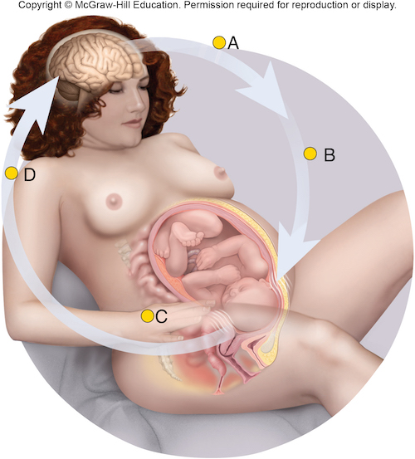

**Question Details**Type : New  
Type : Physiology  
Figure : 01.09

**74.1)** This is an example of which of the following?

A) Positive feedback   
 B) Negative feedback  
 C) Dynamic equilibrium  
 D) Adaptation  
 E) Natural selection

**Question Details**Section : 01.06  
Learning Outcome : 01.06e Define positive feedback and give examples of its beneficial and harmful ef  
Topic : Definition of homeostasis  
Bloom's : 1. Remember  
Type : New  
Type : Physiology  
HAPS Topic : Module B01 Definition of Homeostasis  
HAPS Outcome : B02.03 Compare and contrast positive and negative feedback in terms of the relationshi  
Figure : 01.09

**74.2)** In this feedback loop, what is the receptor?

A) Brain   
 B) Oxytocin  
 C) Uterus  
 D) Ovaries  
 E) Adrenal gland

**Question Details**Section : 01.06  
Learning Outcome : 01.06e Define positive feedback and give examples of its beneficial and harmful ef  
Topic : Definition of homeostasis  
Bloom's : 1. Remember  
Type : New  
Type : Physiology  
HAPS Topic : Module B01 Definition of Homeostasis  
HAPS Outcome : B02.03 Compare and contrast positive and negative feedback in terms of the relationshi  
Figure : 01.09

**74.3)** In this feedback loop, what is the effector?

A) Cervix   
 B) Brain  
 C) Oxytocin  
 D) Uterine muscles  
 E) Ovaries

**Question Details**Bloom's : 3. Apply  
Section : 01.06  
Learning Outcome : 01.06e Define positive feedback and give examples of its beneficial and harmful ef  
Topic : Definition of homeostasis  
Type : New  
Type : Physiology  
HAPS Topic : Module B01 Definition of Homeostasis  
HAPS Outcome : B02.03 Compare and contrast positive and negative feedback in terms of the relationshi  
Figure : 01.09

**75)** Feeling for swollen lymph nodes is an example of auscultation.

⊚ true  
 ⊚ false

**Question Details**Section : 01.01  
Learning Outcome : 01.01b Describe several ways of studying human anatomy.  
Gradable : automatic  
Accessibility : Keyboard Navigation  
Topic : Scope of anatomy and physiology  
Bloom's : 1. Remember  
Type : Anatomy  
HAPS Topic : Module A05 Basic terminology

**76)** We can see through bones with magnetic resonance imaging (MRI).

⊚ true  
 ⊚ false

**Question Details**Section : 01.01  
Learning Outcome : 01.01b Describe several ways of studying human anatomy.  
Gradable : automatic  
Accessibility : Keyboard Navigation  
Topic : Scope of anatomy and physiology  
Bloom's : 1. Remember  
Type : Anatomy  
HAPS Topic : Module A05 Basic terminology

**77)** Histology is the study of structures that can be observed without a magnifying lens.

⊚ true  
 ⊚ false

**Question Details**Section : 01.01  
Learning Outcome : 01.01b Describe several ways of studying human anatomy.  
Gradable : automatic  
Accessibility : Keyboard Navigation  
Topic : Scope of anatomy and physiology  
Bloom's : 1. Remember  
Type : Anatomy  
HAPS Topic : Module A06 Levels of organization  
HAPS Outcome : A06.01 Describe, in order from simplest to most complex, the major levels of organizat

**78)** Cells were first named by microscopist Robert Hooke.

⊚ true  
 ⊚ false

**Question Details**Section : 01.02  
Learning Outcome : 01.02b Describe the contributions of some key people who helped to bring about thi  
Gradable : automatic  
Accessibility : Keyboard Navigation  
Topic : Origins of biomedical science  
Bloom's : 1. Remember  
HAPS Topic : Module A06 Levels of organization

**79)** All functions of the body can be interpreted as the effects of cellular activity.

⊚ true  
 ⊚ false

**Question Details**Section : 01.02  
Learning Outcome : 01.02b Describe the contributions of some key people who helped to bring about thi  
Bloom's : 2. Understand  
Gradable : automatic  
Accessibility : Keyboard Navigation  
Topic : Origins of biomedical science  
Type : Physiology  
HAPS Topic : Module A06 Levels of organization  
HAPS Outcome : A06.01 Describe, in order from simplest to most complex, the major levels of organizat

**80)** The *hypothetico-deductive method* is common in physiology, whereas the *inductive* *method* is common in anatomy.

⊚ true  
 ⊚ false

**Question Details**Bloom's : 3. Apply  
Section : 01.03  
Learning Outcome : 01.03a Describe the inductive and hypothetico-deductive methods of obtaining scien  
Gradable : automatic  
Accessibility : Keyboard Navigation  
Topic : Scientific Method

**81)** An individual scientific fact has more information than a theory.

⊚ true  
 ⊚ false

**Question Details**Section : 01.03  
Bloom's : 2. Understand  
Learning Outcome : 01.03c Explain what is meant by hypothesis, fact, law, and theory in science.  
Gradable : automatic  
Accessibility : Keyboard Navigation  
Topic : Scientific Method  
HAPS Topic : Module A05 Basic terminology

**82)** Evolutionary (Darwinian) medicine traces some of our diseases to our evolutionary past.

⊚ true  
 ⊚ false

**Question Details**Section : 01.04  
Learning Outcome : 01.04a Explain why evolution is relevant to understanding human form and function.  
Gradable : automatic  
Accessibility : Keyboard Navigation  
Topic : Human origins and adaptations  
Bloom's : 1. Remember

**83)** The terms *development* and *evolution* have the same meaning in physiology.

⊚ true  
 ⊚ false

**Question Details**Bloom's : 3. Apply  
Section : 01.04  
Learning Outcome : 01.04b Define evolution and natural selection.  
Gradable : automatic  
Accessibility : Keyboard Navigation  
Topic : Human origins and adaptations  
Type : Physiology

**84)** Organs are made of tissues.

⊚ true  
 ⊚ false

**Question Details**Section : 01.05  
Learning Outcome : 01.05a List the levels of human structure from the most complex to the simplest.  
Gradable : automatic  
Accessibility : Keyboard Navigation  
Topic : Scope of anatomy and physiology  
Bloom's : 1. Remember  
Type : Anatomy  
HAPS Topic : Module A06 Levels of organization  
HAPS Outcome : A06.01 Describe, in order from simplest to most complex, the major levels of organizat

**85)** A molecule of water is more complex than a mitochondrion (organelle).

⊚ true  
 ⊚ false

**Question Details**Bloom's : 3. Apply  
Section : 01.05  
Learning Outcome : 01.05a List the levels of human structure from the most complex to the simplest.  
Gradable : automatic  
Accessibility : Keyboard Navigation  
Topic : Scope of anatomy and physiology  
Type : Anatomy  
HAPS Topic : Module A06 Levels of organization  
HAPS Outcome : A06.01 Describe, in order from simplest to most complex, the major levels of organizat

**86)** Homeostasis and occupying space are both unique characteristics of living things.

⊚ true  
 ⊚ false

**Question Details**Bloom's : 3. Apply  
Section : 01.06  
Learning Outcome : 01.06a State the characteristics that distinguish living organisms from nonliving  
Gradable : automatic  
Accessibility : Keyboard Navigation  
Topic : Scope of anatomy and physiology  
Type : Physiology

**87)** Negative feedback is a self-amplifying chain of events that tends to produce rapid change in the body.

⊚ true  
 ⊚ false

**Question Details**Bloom's : 2. Understand  
Section : 01.06  
Learning Outcome : 01.06d Define negative feedback, give an example of it, and explain its importance  
Gradable : automatic  
Accessibility : Keyboard Navigation  
Topic : Types of homeostatic mechanisms  
Type : Physiology  
HAPS Topic : Module B02 General types of homeostatic mechanisms  
HAPS Outcome : B02.03 Compare and contrast positive and negative feedback in terms of the relationshi

**88)** Positive feedback helps to restore normal function when one of the body's physiological variables gets out of balance.

⊚ true  
 ⊚ false

**Question Details**Bloom's : 2. Understand  
Section : 01.06  
Learning Outcome : 01.06e Define positive feedback and give examples of its beneficial and harmful ef  
Gradable : automatic  
Accessibility : Keyboard Navigation  
Topic : Types of homeostatic mechanisms  
Type : Physiology  
HAPS Topic : Module B02 General types of homeostatic mechanisms  
HAPS Outcome : B02.03 Compare and contrast positive and negative feedback in terms of the relationshi

**89)** Anatomists around the world adhere to a lexicon of standard international terms which stipulates both Latin names and accepted English equivalents.

⊚ true  
 ⊚ false

**Question Details**Section : 01.07  
Learning Outcome : 01.07a Explain why modern anatomical terminology is so heavily based on Greek and  
Gradable : automatic  
Accessibility : Keyboard Navigation  
Topic : Scope of anatomy and physiology  
Bloom's : 1. Remember  
Type : Anatomy  
HAPS Topic : Module A05 Basic terminology

**90)** Lou Gehrig disease is the eponym for Amyotropic Lateral Sclerosis, made famous by the "ice bucket challege."

⊚ true  
 ⊚ false

**Question Details**Bloom's : 3. Apply  
Section : 01.07  
Learning Outcome : 01.07b Recognize eponyms when you see them.  
Gradable : automatic  
Accessibility : Keyboard Navigation  
Topic : Scope of anatomy and physiology  
Type : Anatomy  
HAPS Topic : Module A05 Basic terminology

**91)** Sometimes anatomical terms come from origins that do ***not*** lend any insight into their meaning.

⊚ true  
 ⊚ false

**Question Details**Section : 01.07  
Learning Outcome : 01.07e State some reasons why the literal meaning of a word may not lend to insigh  
Gradable : automatic  
Accessibility : Keyboard Navigation  
Topic : Scope of anatomy and physiology  
Bloom's : 1. Remember  
Type : Anatomy  
HAPS Topic : Module A05 Basic terminology

**Answer Key**Test name: Chapter 01 Test Bank

1) B

2) E

3) D

4) D

5) A

6) A

7) C

8) E

9) D

10) E

11) A

12) C

13) B

14) C

15) B

16) B

17) D

18) B

19) D

20) D

21) E

22) A

23) D

24) B

25) E

26) C

27) E

28) E

29) B

30) B

31) C

32) D

33) B

34) E

35) C

36) E

37) E

38) B

39) C

40) D

41) D

42) C

43) C

44) C

45) C

46) E

47) A

48) C

49) A

50) A

51) A

52) B

53) A

54) A

55) A

56) A

57) A

58) A

59) D

60) A

61) E

62) A

63) A

64) A

65) B

66) D

67) B

68) C

Go to APR 3.0 for further information.

69) D

Go to APR 3.0 for further information.

70) Section Break

70.1) B

70.2) D

70.3) E

70.4) A

71) Section Break

71.1) A

71.2) D

71.3) B

71.4) C

72) Section Break

72.1) A

72.2) C

72.3) D

72.4) B

72.5) E

73) Section Break

73.1) B

73.2) A

73.3) A

73.4) B

73.5) D

73.6) A

73.7) E

74) Section Break

74.1) A

74.2) A

74.3) D

75) FALSE

76) TRUE

77) FALSE

78) TRUE

79) TRUE

80) TRUE

81) FALSE

82) TRUE

83) FALSE

84) TRUE

85) FALSE

86) FALSE

87) FALSE

88) FALSE

89) TRUE

90) TRUE

91) TRUE